|  |  |  |
| --- | --- | --- |
| Parameters | Values | Units |
| Rth (j-c) IGBT | 0.066 | K/W |
| Rth(j-c) FWD | 0.120 | K/W |
| Rth(case)1 | 0.000001 | K/W |
| Rth(case)2 | 0.000001 | K/W |
| Rth(case)3 | 0.000001 | K/W |
| Rth(paste) | 0.015 | K/W |
| Rth(heatsink) | 0.005 – 0.05 | K/W |

|  |  |  |
| --- | --- | --- |
| Pss | 116.065 | W |
| Psw | 116.18 | W |
| Total Power loss of each IGBT | 232.25 | W |
| PDC | 30.54 | W |
| Prr | 11.25 | W |
| Total Power loss of each FWD | 41.79 | W |

|  |  |  |
| --- | --- | --- |
| Esw(on) | 41 | mJ |
| Esw(off) | 32 | mJ |
| Fsw | 5 | kHz |
| Icp | 300 | A |
| VCE(sat) | 2 | V |
| VEC | 1.8 | V |
| D | 0.85 |  |
| θ | 25.842 | Degrees |
| Irr | 200 | A |
| trr | 300 | ns |
| VCE(pk) | 300 | V |

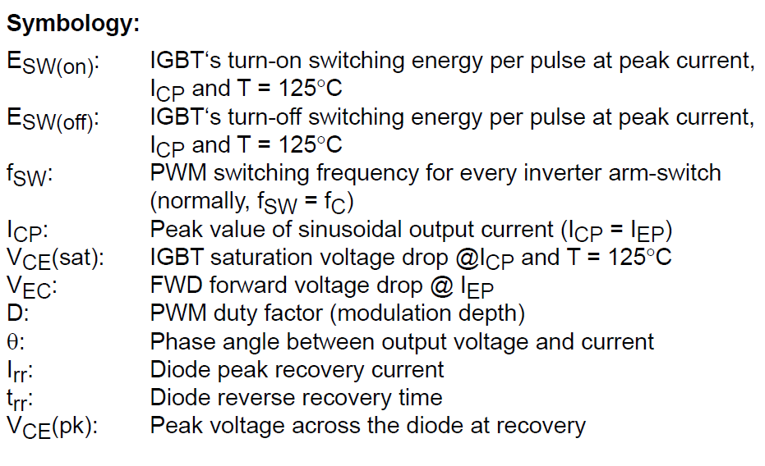

**Pss:** Steady-state loss per switching IGBT

**Psw:** Switching loss per switching IGBT

**PDC:** Steady-state loss per diode

**Prr:** Recovery loss per diode

**Rth (j-c):** thermal resistance junction to case

**Tj IGBT 1U:** Junction temperature of the upper IGBT of the phase 1

**Tj IGBT 1L:** Junction temperature of the lower IGBT of the phase 1

**Tj FWD 1U:** Junction temperature of the upper free-wheeling diode of the phase 1

**Tj FWD 1L:** Junction temperature of the lower free-wheeling diode of the phase 1

|  |  |  |  |  |  |  |
| --- | --- | --- | --- | --- | --- | --- |
| **Data** | **Rth(heatsink) K/W** | **Tj IGBT (celcius)** | **Tj FWD(celcius)** | **T(case)** | **T(heatsink)** | **Ta** |
| 1 | 0.005 | 75.64 | 100.8 | 72.88 | 48.22 | 40 |
| 2 | 0.006 | 77.29 | 102.4 | 74.53 | 49.87 | 40 |
| 3 | 0.007 | 78.93 | 104 | 76.17 | 51.5 | 40 |
| 4 | 0.008 | 80.58 | 105.7 | 77.82 | 53.15 | 40 |
| 5 | 0.009 | 82.22 | 107.3 | 79.46 | 54.8 | 40 |
| 6 | 0.010 | 83.66 | 109 | 81.11 | 56.44 | 40 |
| 7 | 0.012 | 87.15 | 112.3 | 84.39 | 59.73 | 40 |
| 8 | 0.015 | 92.09 | 117.2 | 89.33 | 64.66 | 40 |
| 9 | 0.017 | 95.37 | 120.5 | 92.62 | 67.95 | 40 |
| **10** | **0.020** | **100.3** | **125.4** | **97.55** | **72.88** | **40** |
| 11 | 0.022 | 103.6 | 128.7 | 100.8 | 76.17 | 40 |
| 12 | 0.025 | 108.5 | 133.6 | 105.8 | 81.11 | 40 |
| 13 | 0.027 | 111.8 | 136.9 | 109.1 | 84.39 | 40 |
| 14 | 0.030 | 116.7 | 141.9 | 114 | 89.33 | 40 |
| 15 | 0.032 | 120 | 145.1 | 117.3 | 92.62 | 40 |
| 16 | 0.035 | 125 | 150 | 122.2 | 97.55 | 40 |
| 17 | 0.037 | 128.3 | 153.4 | 125.5 | 100.8 | 40 |
| 18 | 0.040 | 133.2 | 158.3 | 130.4 | 105.8 | 40 |
| 19 | 0.042 | 136.5 | 161.6 | 133.7 | 109.1 | 40 |
| 20 | 0.045 | 141.4 | 166.5 | 138.7 | 114 | 40 |
| 21 | 0.047 | 144.7 | 169.8 | 141.9 | 117.3 | 40 |
| 22 | 0.050 | 149.6 | 174.7 | 146.9 | 122.2 | 40 |

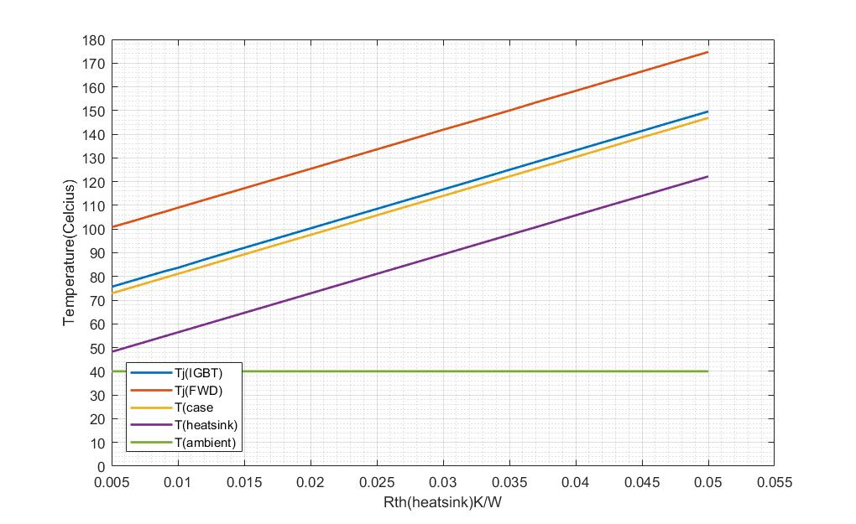

* Tj(FWD) = 125.4 ℃ when Rth(heatsink) = 0.02 K/W